**FOOT STEP POWER GENERATION SYSTEM FOR RURAL ENERGY APPLICATION TO RUN AC AND DC LOADS**

**ABSTRACT:**

Man has needed and used energy at an increasing rate for his sustenance and well being ever since he came on the earth a few million years ago. Due to this a lot of energy resources have been exhausted and wasted. Proposal for the utilization of waste energy of foot power with human locomotion is very much relevant and important for highly populated countries like India and China where the roads, railway stations, bus stands, temples, etc. are all over crowded and millions of people move around the clock. This whole human/ bio-energy being wasted if can be made possible for utilization it will be great invention and crowd energy farms will be very useful energy sources in crowded countries.

In this project we are generating electrical power as non-conventional method by simply walking or running on the foot step. Non-conventional energy system is very essential at this time to our nation. Non-conventional energy using foot step is converting mechanical energy into the electrical energy. This project uses piezoelectric sensor.

In this project the conversion of the force energy in to electrical energy. The control mechanism carries the piezoelectric sensor, A.C ripples neutralizer, unidirectional current controller and 12V, 1.3Amp lead acid dc rechargeable battery and an inverter is used to drive AC/DC loads. The battery is connected to the inverter. This inverter is used to convert the 12 Volt D.C to the 230 Volt A.C.

This 230 Volt A.C voltage is used to activate the loads. We are using conventional battery charging unit also for giving supply to the circuitry.

This project uses regulated 5V, 500mA power supply. 7805 three terminal voltage regulator is used for voltage regulation. Bridge type full wave rectifier is used to rectify the ac output of secondary of 230/12V step down transformer.

**BLOCK DIAGRAM:**

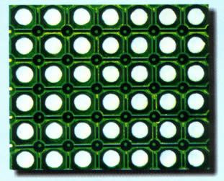

AC RIPPLE NEUTRALIZER

**PIR SENSOR**

**ARRAY**

UNIDIRECTIONAL CURRENT CONTROLLER

**Step Down**

**Transformer**

**Bridge**

**Rectifier**

**Filter**

**Circuit**

**Regulator section**

RECHARGEABLE BATTERY

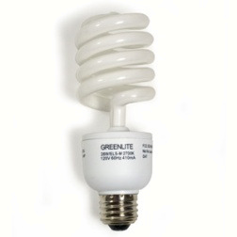

STEP UP

TRANSFORMER

LOAD

MOSFET DRIVER

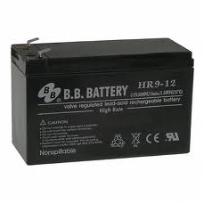

DECADE

IC